Name: Pheakdey Luk **Assignment 9**

ID: 986591

R-3.11 Consider the following sequence of keys:  
(5, 16, 22, 45, 2, 10, 18, 30, 50, 12, 1)

Consider the insertion of items with this set of keys, in the order given, into: a. an initially empty (2,4) tree T’.  
b. an initially empty red-black tree T’’.

Draw T’ and T’’ after each insertion.

**Answer:**

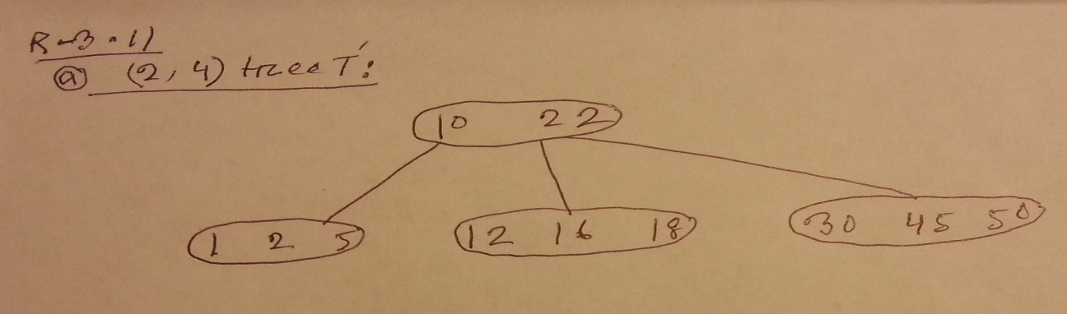

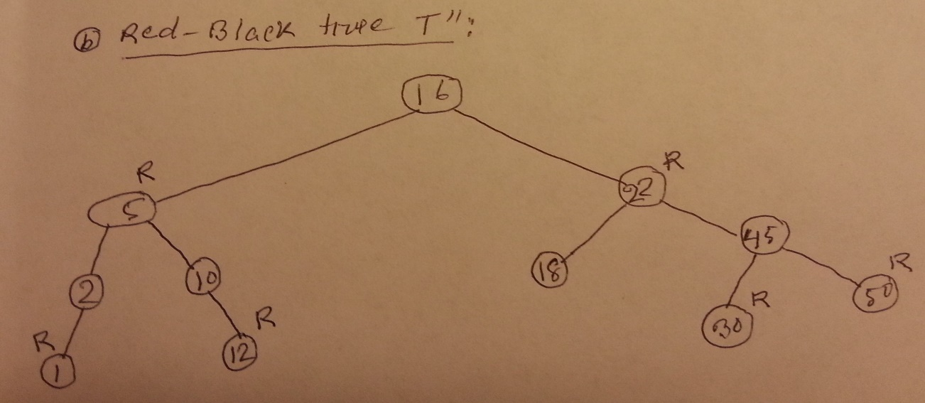

R-3.14 For each of the following statements about red-black trees, determine whether it is true or false. If you think if it is true, provide a justification. If you think it is false, give a counterexample.

|  |  |
| --- | --- |
| a | False.  Reason: To be a red-black root has to be black but there is no guarantee root of subtree will be black. It might be red or black. |
| b | True.  Reason: if by another external node it is a black external nodes, because there's a rule that all external nodes are black. And also it can be red, because when we insert, or doing recolor, or restructure, the node will still be red. |
| c | False.  Reason: Every red-black tree can become (2,4) tree, and the other way around. But we can make the tree with the same red black tree and produce a different (2,4) tree, even though it's result will be the same. So basically, it's not unique. |
| d | False.  Reason:  Every (2,4) tree can become red-black tree, and the other way around. But we can make the tree with the same (2,4) tree and produce a different red black tree, even though it's result will be the same. So basically, it's not unique. |

a. a subtree of a red-black tree is itself a red-black tree.  
b. the sibling of an external node is either external or it is red.  
c. given a red-black tree T, there is an unique (2,4) tree T’ associated with T. d. given a (2,4) tree T, there is an unique red-black tree T’ associated with T.

Design a pseudo code algorithm isValidAVL(T) that decides whether or not a binary tree is a valid AVL tree. For this problem, we define valid to mean that the height of the left and right sub-trees of every node do not differ by more than one.

What is the time complexity of your algorithm?

Design an algorithm, isPermutation(A,B) that takes two sequences A and B and determines whether or not they are permutations of each other, i.e., they contain same elements but possibly occurring in a different order. Assume the elements in A and B cannot be sorted. Hint: A and B may contain duplicates. Same problem as in previous homework, but this time use a dictionary to solve the problem.

What is the worst case time complexity of your algorithm? Justify your answer.

C-3.10 Let D be an ordered dictionary with n items implemented by means of an AVL tree (or a Red-Black tree). Show how to implement the following operation on D in time O(log n + s), where s is the size of the iterator returned:

FindAllInRange(k1, k2):  
Return an iterator of all the elements in D with key k such that k1 < k < k2.

**Answer:**

|  |  |
| --- | --- |
| Algorithm findAllInRange**(**k1**,**k2**)**  Input**:** key k1**,** k2  Ouput**:** return iterator **for** all the elements in D within the range of k1 and k2  T**<-** tree of D  S**<-**findElements**(**T**,**T**.**root**(),**k1**,**k2**)**  **return** S**.**iterator**()** | Algorithm findElements**(**T**,**p**,**k1**,**k2**)**  Input**:** Tree T**,** position of a node p**,** key k1**,** k2  Output**:** Sequence S with all the elements between the range of k1 and k2 inclusive**.**  S**<-new** Sequence  k **<-** T**.**key**(**p**)**  **if** k1 **<=** k **^** k **<=** k2 then  S**.**insertLast**(**D**.**findElement**(**k**))**  findElements**(**T**,**T**.**leftChild**(**p**),**k1**,**k2**)**  findElements**(**T**,**T**.**rightChild**(**p**),**k1**,**k2**)**  **else** **if** k **<** k1 then  **return** findElements**(**T**,**T**.**leftChild**(**p**),**k1**,**k2**)**  **return** S |